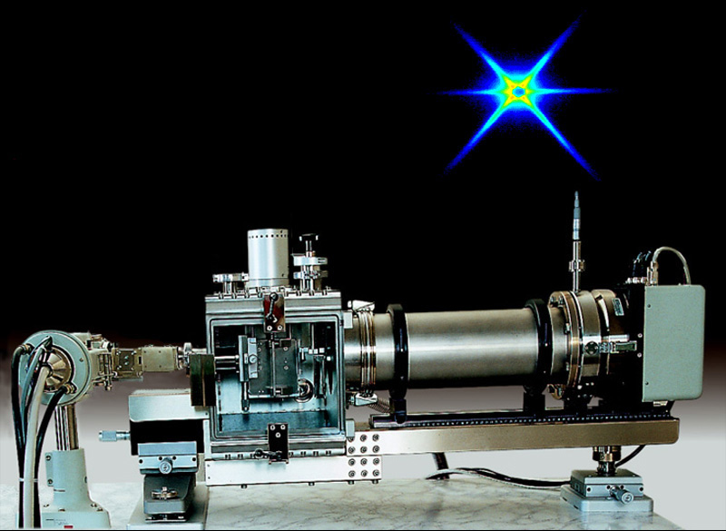

Second International Workshop

SAXS with NanoSTAR
First Circular

June 15-17, 2000
Leoben
Austria

Organizer: Prof. Peter Fratzl
Erich Schmid Institute for Materials Science, Austrian Academy of Sciences
Metal Physics Institute, University of Leoben
Leoben, Austria

Co-organizers:

Material Center Leoben GmbH
Franz Josef Straße 13
A-8700 Leoben, Austria

Bruker AXS GmbH
Östl. Rheinbrückenstr. 50
D-76181 Karlsruhe, Germany
www.bruker-axs.de

Anton Paar GmbH
Kärntnerstraße 322
A-8054 Graz, Austria
www.anton-paar.com

Aim:
Introduction to the characterization of (anisotropic) structures in the nanometer range by the methods of small-angle x-ray scattering. In addition to lectures by experts in the field, there will be an emphasis on practical training to provide hands-on experience with SAXS-techniques in general and the NanoSTAR system in particular. Measurement and data evaluation of a limited number of specimens from participants will be performed.
The NanoSTAR system is based on a combination of latest x-ray optics technology (Göbel mirrors), high-precision mechanics (optical bench with high-resolution pinhole camera), a 2-dimensional detector (HI-STAR) and a powerful software package (SAXS NT) for data acquisition and evaluation. Its advantages are high intensities, short measuring times, easy operation and sample handling, no slit-smearing offering the possibility to measure nearly any kind of specimens (anisotropic samples, dilute solutions, powders, ...) and a long-term stability.

Provisional list of speakers:

V. Abetz University Bayreuth, D
K. Erlacher Material Center Leoben, A

P. Fratzl University Leoben, A
R. Goergl Anton Paar GmbH, A
J. S. Pedersen Risoe National Laboratory, DK
U. Wiesner Cornell University, USA
Workshop Secretariat:

DI Kurt Erlacher
Material Center Leoben
c/o Erich Schmid Institute
for Materials Science
Jahnstraße 12, A-8700 Leoben
Phone: +43 3842 45511 31
Fax: +43 3842 45512 6
Email: kurt.erlacher@unileoben.ac.at

Dr. Richard Goergl
Anton Paar GmbH
c/o Erich Schmid Institute
for Materials Science
Jahnstraße 12, A-8700 Leoben
Phone: +43 3842 45511 52
Fax: +43 3842 45512 6
Email: richard.goergl@unileoben.ac.at

Location:

Erich Schmid Institute for Materials Science, Austrian Academy of Sciences

Jahnstraße 12
A-8700 Leoben, Austria

Number of Participants:
To enable efficient practical courses, the number of participants is limited to 30. Due to the restricted number of participants registration will be accepted in the order of their arrival.

Registration Fee:
The Registration fee: 400.- Euro
will cover the workshop proceedings, accommodation and all meals.

Pre-registration:

Deadline: March 1, 2000
To ensure the participation send an email to the Workshop Secretariat or return the filled pre-registration form.

Final Registration and Payment of Registration Fee:
Deadline: April 15, 2000

For up to date information, please visit our homepage at
http://www.oeaw.ac.at/esi/english/events/Workshop-2000.html
For detailed information on the NanoSTAR system and other x-ray devices visit the homepages of Bruker AXS GmbH and Anton Paar GmbH.

The second circular will be sent to all pre-registered participants by April 1st.
Please fill the form and return it before March 1, 2000 to the Workshop Secretariat.

SAXS with NanoSTAR

Pre-Registration

Surname:
First Name:
Title/Position:
Company/Institution:

Adress:

Phone:
Fax:
Email:

Knowledge in scattering methods

- Newcomer
- Basic Knowledge
- Advanced User

I will bring my own samples

- Yes
- No

If yes, short description of sample:

