Summer School : EXTREME MATTER

The general context of this school is the study of Warm Dense Matter generated by high power lasers. This state of matter is defined by temperatures T ~ 0.1 - 100 eV, densities ρ ~ 0.1 - 10 times the solid density, and pressures ≥ Mbar. The macroscopic and microscopic study of this matter concerns a very broad field of physics, ranging from fundamental physics to inertial confinement fusion, as well as planetology and geophysics. The theme of this school is in full expansion thanks to the evolution of laser facilities as well as the development of installations providing X-ray sources well adapted to characterize matter in extreme conditions (e.g. ESRF or EUXFEL).
The scientific objective is giving a detailed presentation of the complex physics involved, thanks to general lessons and also lessons dedicated to applications (such as amazing breakthrough obtained recently on NIF laser where fusion reaction has yielded more energy than it took to spark it). Lessons will be associated to practical works with the aim to train students and researchers to design a typical high power laser compression experiment and to analyze main data.

The school will be held at the Observatoire Oceanographique of Banyuls sur Mer, France, 4-8 september 2023.
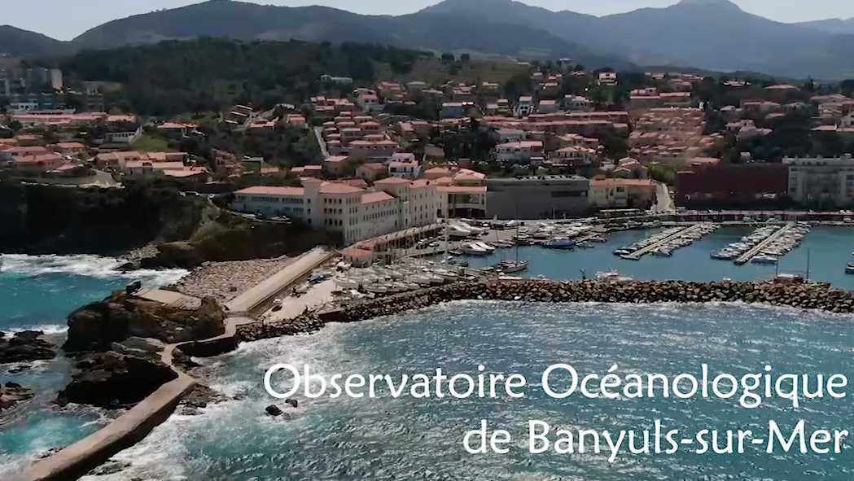

Banyuls sur Mer is a charming village on the Mediterranean Sea. It is known for its vineyards that flow into the sea and produce a delicious sweet wine, its seabed that made it the first French Marine Nature Reserve in 1974, its small beaches and century-old olive groves.

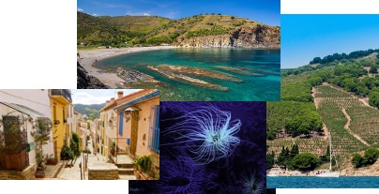

See : https://www.obs-banyuls.fr/en/host/congress-and-seminar.html
Further information will be given soon.

Organizers: A. Benuzzi (alessandra.benuzzi-mounaix@polytechnique.edu), F. Dorchies, R. Torchio, V. Recoules, T. Vinci

The speakers that already accepted to give lessons are:

D. Kraus
A. Ravasio
A. Denoeud
G. Morard
J. A. Hernandez
M. Harmand
S. Le Pape
….

